Ridge Regression
The objective function (also called the cost) to be minimized is the RSS plus the sum of square of the magnitude of weights. This can be depicted mathematically as:
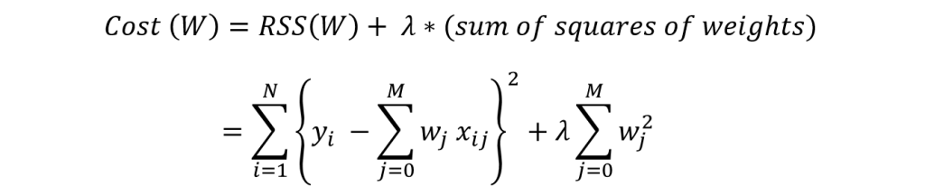
In this case, the gradient would be:
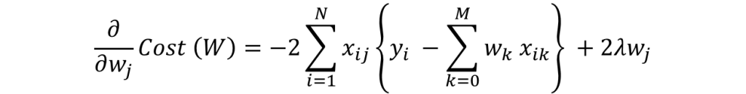

Again in the regularization part of gradient, only wj remains and all other would become zero. The corresponding update rule is:
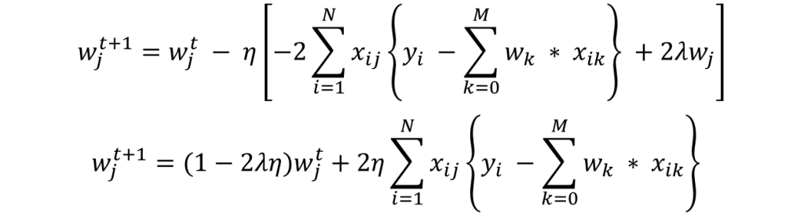

Here we can see that second part of the RHS is same as that of simple linear regression. Thus, ridge regression is equivalent to reducing the weight by a factor of (1-2λη) first and then applying the same update rule as simple linear regression. I hope this gives some intuition into why the coefficients get reduced to small numbers but never become zero.
Note that the criteria for convergence in this case remains similar to simple linear regression, i.e. checking the value of gradients. Lets discuss Lasso regression now.

Lasso Regression
The objective function (also called the cost) to be minimized is the RSS plus the sum of absolute value of the magnitude of weights. This can be depicted mathematically as:
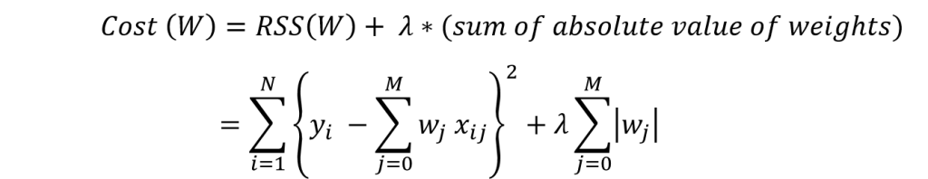
In this case, the gradient is not defined as the absolute function is not differentiable at x=0. This can be illustrated as:
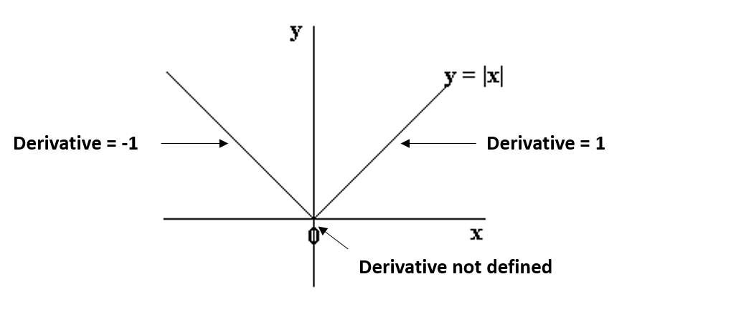
We can see that the parts on the left and right side of 0 are straight lines with defined derivates but the function can’t be differentiated at x=0. In this case, we have to use a different technique called as coordinate descent which is based on the concept of sub-gradients. One of the coordinate descent follows the following algorithms (this is also the default in sklearn):
1. initialize weights (say w=0)
2. iterate till not converged
2.1 iterate over all features (j=0,1...M)
2.1.1 update the jth weight with a value which minimizes the cost
#2.1.1 might look too generalized. But I’m intentionally leaving the details and jumping to the update rule:
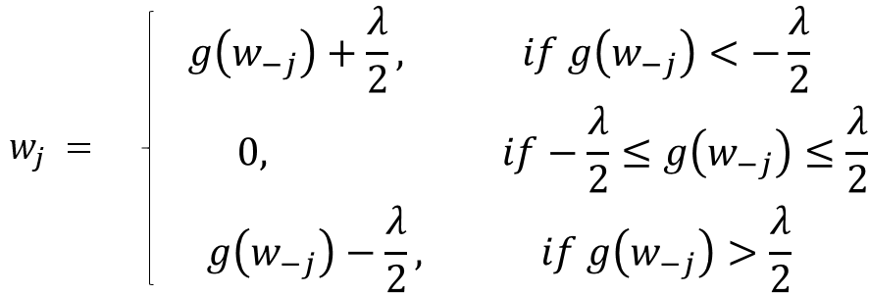
Here g(w-j) represents (but not exactly) the difference between actual outcome and the predicted outcome considering all EXCEPT the jth variable. If this value is small, it means that the algorithm is able to predict the outcome fairly well even without the jth variable and thus it can be removed from the equation by setting a zero coefficient. This gives us some intuition into why the coefficients become zero in case of lasso regression.
In coordinate descent, checking convergence is another issue. Since gradients are not defined, we need an alternate method. Many alternatives exist but the simplest one is to check the step size of the algorithm. We can check the maximum difference in weights in any particular cycle over all feature weights
The convergence is not as fast as gradient descent and we might have to set the ‘max_iter’ parameter if a warning appears saying that the algo stopped before convergence. This is why I specified this parameter in the Lasso generic function.
Lets summarize our understanding by comparing the coefficients in all the three cases using the following visual, which shows how the ridge and lasso coefficients behave in comparison to the simple linear regression case.
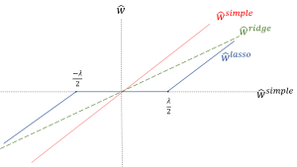
Apologies for the lack of visual appeal. But I think it is good enough to re-inforced the following facts:
- The ridge coefficients are a reduced factor of the simple linear regression coefficients and thus never attain zero values but very small values
- The lasso coefficients become zero in a certain range and are reduced by a constant factor, which explains there low magnitude in comparison to ridge.
Before going further, one important issue in case of both ridge and lasso regression is intercept handling. Generally, regularizing the intercept is not a good idea and it should be left out of regularization. This requires slight changes in the implementation, which I’ll leave for you to explore.

